Certificate of Approval

This is to certify that, following are confide students of S. Tech in Mechanical Department. They have satisfactorily completed the requirements of Capstone Project for the courses Sem III Mechanical as prescribed by ST. JOHN COLLEGE OF ENGINEERING AND MANAGEMENT (An Autonomous College affiliated to University of Mumbai), while working on “Prototype of Shoe Drying Machine”.

Krish N. Patil [EU1255031.]
Parikshitsingh K. Rathod [EU1255002]
Bhavesh G. Pant [EU1255010]
Saurabh G. Singh [EU1255001]

Project Guide:
Name: Mr. Chirag Kale
Signature: ____________________
Date: ____________________

HOD :
Name:Dr. Kishor Rambhad
Signature: ____________________
Date: ____________________

Name: Dr. Kamal Shah Principal,
Signature: ____________________
St. John College of Engineering and Management.

St. John College of Engineering & Management
Department of Mechanical Engineering

CAPSTONE PROJECT REPORT
ON
PROTOTYPE DEVELOPMENT OF A SHOE DRYING MACHINE
S.Tech Mechanical Engineering (SEM III)
Submitted by:
1. Bhavesh G. Pant [33]
2. Krish N. Patil [39]
3. Parikshitsingh K. Rathod [46]
4. Saurabh G. Singh [53]

Project Guide:
Mr. Chirag Kale
Department of Mechanical Engineering
Academic Year: 2026-202
STUDENT DECLARATION

I/we declare that this written submission represents my/our ideas in my/our own words and where others ideas or words have been included, I/we have adequately cited and referenced the original sources. I/we also declare that I/we have adhered to all principles of academic honesty and integrity and have not misrepresented or fabricated or falsified any idea/data/fact/source in my/our submission. I/we understand that any violation of the above will be cause for disciplinary action by the Institute and can also evoke penal action from the sources which have thus not been properly cited or from whom proper permission has not been taken when needed.

Krish N. Patil [EU1255031] Signatures:

Parikshitsingh K. Rathod [EU1255002] Signatures:

Bhavesh G. Pant [EU1255010] Signatures:

Saurabh G. Singh [EU1255001] Signatures:

Date:

ACKNOWLEDGEMENT
We sincerely thank to our guide Mr.Chirag Kale for her guidance and support for carrying out our project work.

We express our sincere gratitude to our project guide, guide Mr.Chirag Kale, for guidance, encouragement and valuable suggestions throughout this project.
We thank the Head of the Department of Mechanical Engineering, Dr. Kishor Rambhad
and the faculty members of the department for their support and for providing the facilities needed to carry out this work.
We are thankful to the workshop and laboratory staff for their help during the fabrication and assembly of the prototype, and to St. John College of Engineering & Management for providing the opportunity and resources for this project.

Student name:

Krish N. Patil
Parikshitsingh K. Rathod
Bhavesh G. Pant
Saurabh G. Singh

Note: While writing the acknowledgement all students are supposed to follow the hierarchy in the order of principal, Mentor Dean, HOD, guide, colleague, parents as applicable.

ABSTRACT

Wet footwear dries slowly in ambient conditions, and natural drying depends on the weather. This project covers the design, three-dimensional solid modelling and prototype development of a shoe drying machine that holds one pair of shoes and uses fan-assisted warm air to speed up drying.
The machine was modelled in SolidWorks, with individual components and a complete assembly (Project Cap.SLDASM). Plywood was selected for the outer housing and PVC pipe for air distribution, chosen for low cost, availability and ease of fabrication. In the intended operation, a fan moves air over a heating element, and two PVC pipes direct the warm air towards the shoes; humid air leaves through an outlet in the side wall. The heater is intended for a 230 V AC supply and the fan for a 12 V DC supply.
A physical prototype has been fabricated and assembled following the CAD model. An air temperature of approximately 40–45 °C has been reported, but this value is preliminary because its measurement method and location are yet to be confirmed. Quantitative performance data, such as airflow, drying time, moisture removal and energy consumption, are not yet documented; the report therefore provides the calculation methods, a test procedure and blank observation tables, and makes no claim about drying time, efficiency or performance improvement.
The report also discusses the limitations of plywood (combustibility) and PVC (temperature limit) near a heater, and recommends safety measures and future improvements, including temperature control, a timer, humidity monitoring, improved airflow, energy monitoring and better thermal design. These are recommendations and are not described as implemented features.
Keywords: shoe dryer, SolidWorks, solid modelling, forced convection, prototype, plywood, PVC.

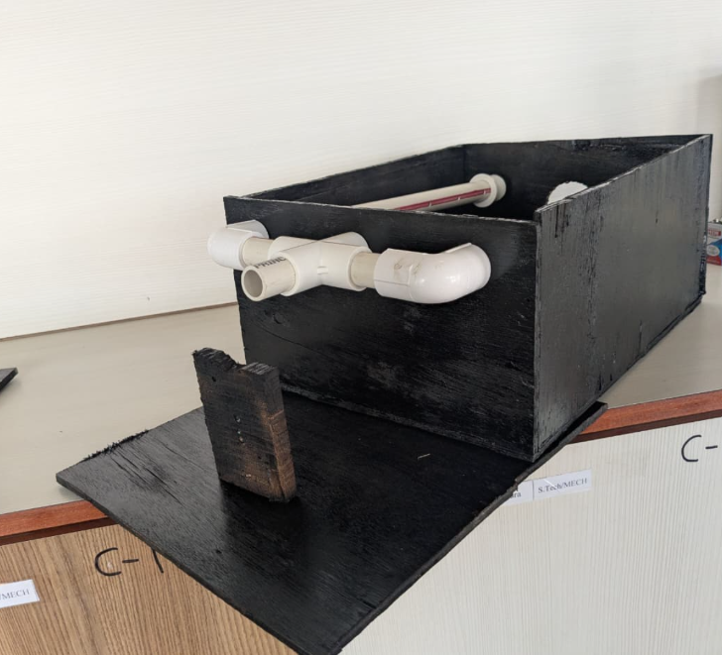
Prototype of Shoe Drying Machine

CHAPTER 1: INTRODUCTION

1.1 Background of Shoe Drying
Footwear that becomes wet, whether through rain, perspiration, washing or exposure to damp conditions, takes a long time to dry at ambient conditions because the moisture is held within porous layers such as fabric, foam, leather and insoles. Prolonged dampness is undesirable: it can cause odour, promote microbial growth, shorten the useful life of the shoe, and make footwear uncomfortable or unusable at short notice.
Shoes are most commonly dried by leaving them in open air, in sunlight, or near a fan or heater. These methods depend on weather, are slow, and are difficult to control. A compact, enclosed device that circulates warm air around the shoe provides a more predictable and weather-independent alternative, and is a suitable subject for a mechanical engineering project because it involves heat transfer, fluid flow, material selection, enclosure design and basic electrical integration.

1.2 Problem Statement
To design, model and build a low-cost, compact shoe drying machine, capable of holding one pair of shoes, that uses a fan and a heating element to deliver warm air to the shoes through two PVC pipes, with the outer housing made of plywood and the design documented through a SolidWorks 3D solid model and assembly.

1.3 Need for the Project
- Natural drying is slow and weather-dependent, particularly in the monsoon season.
- Commercial shoe dryers are not always available locally, and their internal construction is rarely documented for learning purposes.
- The project offers a complete product-development exercise, from concept and CAD to fabrication and testing, within a student workshop environment using readily available materials.

1.4 Aim and Objectives
Aim: To design, model in SolidWorks, fabricate and document a prototype shoe drying machine.
Objectives:
- To define user requirements, design objectives and constraints for a one-pair shoe drying machine.
- To develop a 3D solid model of each component and a complete assembly using SolidWorks.
- To select suitable low-cost materials (plywood housing, PVC air-distribution s) and to examine their limitations near a heat source.
- To fabricate and assemble a physical prototype based on the CAD model.
- To define a systematic test procedure for temperature, airflow, drying time and energy use, and to record the data that has been collected so far.
- To identify limitations and suggest improvements for future work.

1.5 Scope of the Project
The scope covers conceptual design, 3D modelling and assembly in SolidWorks, preparation of manufacturing information, fabrication of one prototype, and definition of a test methodology. The prototype is sized for one pair of shoes. Quantitative performance data (drying time, airflow, energy consumption) are not yet fully documented; where they are missing, this report provides the calculation method and blank observation tables rather than estimated results.

1.6 Applications
- Domestic drying of school, sports and casual footwear.
- Hostels, small gyms and sports clubs where shoes must be dried between uses.
- Educational demonstration of forced convection, drying and product-development workflow.

1.7 Significance of the Project
The project integrates several mechanical engineering topics in one product: geometric modelling and assembly (CAD), thermal engineering (convective heating and evaporation), fluid flow (air distribution), material selection, manufacturing processes (cutting and joining of plywood and PVC) and electrical safety awareness. It also demonstrates how a CAD model is used to plan fabrication and control dimensions before material is cut.

1.8 Limitations
- Capacity is limited to one pair of shoes.
- Quantitative performance (drying time, energy consumption, thermal efficiency) has not yet been fully documented.
- The reported air temperature of about 40–45 °C is preliminary; its measurement method and location are yet to be confirmed.
- Plywood is combustible and PVC has a limited service temperature; the safety measures needed for sustained operation are discussed in Chapter 12 as recommendations, not as installed features.

1.9 Expected Outcomes
- A complete SolidWorks part and assembly model of the shoe drying machine.
- A fabricated prototype that follows the CAD model, with documented deviations.
- A documented test methodology and observation sheets ready for data entry.
- A list of safety recommendations and future improvements.

1.10 Importance of Combining CAD Modelling with Prototype Development
A virtual model alone cannot reveal practical issues such as fitment of a fan in its opening, the effort needed to cut a pipe entry through plywood, or how wiring is routed. A prototype alone, built without a model, tends to be dimensionally inconsistent and difficult to reproduce or modify. Combining the two allows dimensions, clearances and component positions to be checked in the model before cutting material, and then allows the prototype to feedback real fabrication observations into the model. This build-model-compare loop is central to practical mechanical engineering design, and it is the approach followed in this project.

CHAPTER 2: LITERATURE REVIEW
This chapter summarises established background knowledge relevant to the project. It draws on standard textbooks and handbooks rather than on specific journal papers; the references listed at the end of the report are standard texts whose bibliographic details (edition and year) should be confirmed against the copies used by the project team.

2.1 Existing Shoe Drying Techniques
Common approaches include air drying at room temperature, drying near a household fan, placing shoes near a room heater or radiator, stuffing shoes with absorbent material such as newspaper, and using commercial electric shoe dryers. Domestic dryers typically combine a heating element with either natural convection or a small fan, and some use warm air delivered into the shoe through tubes or inserts. Informal practices such as placing wet shoes directly on a heater are inefficient and can damage materials.

2.2 Natural and Sunlight Drying
Sunlight drying uses solar radiation and ambient airflow to evaporate moisture. It is free but depends on weather and time of day, offers little control over temperature, and strong ultraviolet exposure and heat can degrade some footwear materials such as certain rubbers, adhesives and dyes. It is not usable at night or during the rainy season, which is precisely when the need is greatest.

2.3 Commercial Electric Shoe Dryers
Commercially available electric shoe dryers are usually compact, low-power appliances that deliver warm air at moderate temperatures. Their design typically balances heating power, air delivery and safety features such as thermal cut-outs and insulated housings. Specific models and their specifications vary by manufacturer; for this project, they serve only as a general benchmark, and no comparative performance claims are made.

2.4 Forced Convection and Warm-Air Circulation
In forced convection, a fan moves the fluid over a surface, increasing the convective heat transfer coefficient compared with natural convection [1], [2]. Warm air supplies the sensible heat needed to raise the shoe and its contained moisture to a temperature at which evaporation proceeds more quickly, and the moving air carries the evaporated vapour away from the surface. Directing air through ducts or pipes to specific locations allows warm air to be concentrated where it is needed.

2.5 Heat Transfer and Moisture Evaporation
Drying involves simultaneous heat and mass transfer. Heat is transferred from the air to the wet material by convection; moisture moves from the interior of the material to its surface and is then evaporated into the air, which absorbs it as long as it remains below saturation [3], [4]. The rate of evaporation depends on air temperature, air velocity, the humidity of the incoming air and the nature of the material. As the surface moisture is depleted, drying usually slows because internal moisture movement becomes limiting. Evaporation also requires the latent heat of vaporisation, which is large compared with the sensible heat needed to warm the air, so the energy balance of any dryer is dominated by the moisture to be removed.

2.6 CAD-Based Product Design and Prototyping
Parametric solid modelling tools such as SolidWorks allow components to be created from sketches and features, combined in assemblies using mates, checked for interference, and converted into dimensioned drawings [5]. Using the model to plan fabrication reduces errors and material waste, and it allows design changes to be evaluated virtually before the prototype is modified.

2.7 Material Selection for Low-Cost Enclosures and Air Ducts
Plywood is widely available, easy to cut and fasten, light, and inexpensive, which makes it attractive for prototype enclosures. However, wood-based materials are combustible and can char or ignite if exposed to excessive heat for long periods; their ignition behaviour depends on the product and on the temperature and exposure time [6]. PVC pipe is inexpensive, easy to cut and available in many diameters, but rigid PVC has a limited maximum service temperature and can soften or deform when overheated. The actual rating depends on the product grade and should be confirmed from the manufacturer datasheet for the pipe used. These limitations influence how close the heating element may be to the housing and pipes, and are discussed further in Chapters 7 and 12.

2.8 Research Gaps Addressed by the Project
Much of the available information on drying focuses on industrial dryers or commercial appliances, whereas documentation of a low-cost, workshop-built shoe dryer with a traceable CAD model is limited. This project addresses that gap at a student level by documenting a complete CAD-to-prototype workflow with explicit separation of verified information from assumptions. It does not claim novelty in drying technology, and its contribution is the documented design, model and prototype, together with a structured test plan.

CHAPTER 3: CONCEPT DEVELOPMENT AND DESIGN METHODOLOGY
This chapter describes the development path from problem to prototype. Three things are kept distinct throughout the report: (i) the proposed design, which is the intended concept; (ii) the SolidWorks model, which is the actual CAD representation in Project Capstone Model and (iii) the fabricated prototype, which is the physical machine. They may differ, and any differences are reported in Chapter 5.

3.1 Identification of the Problem
Wet shoes dry slowly under ambient conditions, and no low-cost, weather-independent drying aid was available to the team. The problem was defined as drying one pair of shoes using a fan-assisted warm-air flow within a compact enclosure.

3.2 User Requirements
- Hold one pair of shoes.
- Deliver warm air to the shoes using a fan and heating element.
- Be built from low-cost, easily available materials.
- Be simple to operate and to load and unload.
- Allow moist air to leave the enclosure.

3.3 Concept Generation
Concepts considered at the idea stage were of the following general types: (a) an open frame with a fan and heater blowing across the shoes; (b) an enclosed chamber with a single warm-air inlet; and (c) an enclosed two chamber warm air delivered through small holes in pipes directed towards the shoes.

3.4 Selection of the Proposed Design
The proposed design is an enclosed plywood housing in which a fan drives air over a heating element and the warm air is directed to the shoes through two PVC pipes, with a side-wall outlet for the humid air. Enclosing the shoes limits heat loss to surroundings and keeps the shoes protected, while pipes allow warm air to be directed at the interior of the shoes. The reasons are qualitative; no weighted-decision scoring was supplied, so none is reported.

3.6 Preliminary Component Layout
The intended layout comprises the intake, fan, heating element, two PVC pipes, shoe chamber and side-wall outlet. The exact positions and dimensions are taken from the SolidWorks model and are presented in Chapter 4.

3.7 Material Selection
Plywood was chosen for the housing for its availability, workability and low cost; PVC was chosen for air distribution for its availability, ease of cutting and smooth bore. The limitations of both materials near a heater are examined in Chapters 7 and 12.

3.8 CAD Modelling and Assembly Design
Each component was modelled in SolidWorks and combined in the assembly Project Cap.SLDASM. Details are given in Chapter 4.

3.9 Prototype Fabrication
The prototype was fabricated from plywood panels, PVC pipes and the electrical components. Details are given in Chapter 5.

3.10 Inspection and Testing Methodology
A test procedure covering temperature, airflow, shoe mass loss, drying time, electrical power and ambient conditions is defined in Chapter 9. Quantitative results are not yet documented.

3.11 Methodology Flowchart
Identify problem and user requirements
↓
Define design objectives and constraints
↓
Generate and select concept
↓
Select materials and components
↓
Create SolidWorks part models and assembly
↓
Check dimensions, fit and clearances; prepare drawings
↓
Fabricate and assemble prototype
↓
Inspect, correct and compare prototype with CAD model
↓
Test and evaluate (Chapter 9)
↓
Document results, limitations and future work
Figure 1: Project methodology flowchart

CHAPTER 4: SOLID MODELLING AND ASSEMBLY USING SOLIDWORKS
Status note. The SolidWorks assembly (Project Capstone Model), its part files, drawings and exported views were not available when this report was generated. This chapter therefore describes the modelling workflow in general terms and provides the structure, figure slots and dimension table to be completed from the actual model. Features, mates and checks are listed only as items to be confirmed; none is claimed as performed unless the team confirms it.

4.1 Purpose of Using SolidWorks
SolidWorks is a parametric, feature-based 3D solid modelling package. In this project it was used to create the individual components, assemble them into the complete machine, verify component fit and dimensions, and generate drawings for fabrication [5]. Using a single master model keeps the dimensions consistent between parts and drawings and allows changes to be made in one place.

4.2 Creation of Individual Solid Components
Each physical component is represented by a part file. The list below shows the parts expected from the project description; confirm each against the FeatureManager tree of the assembly and add or remove parts as necessary.
Table 1: Component models in the SolidWorks assembly
No. | Part / component | Geometry
1 | Plywood housing panels (base, sides, top, etc.) | 150 x 250mm & 250 x 350 mm
2 | PVC pipe 1 | 20.41 mm (Diameter)
3 | PVC pipe 2 | 20.41 mm (Diameter)
4 | Fan | 25 mm (Diameter)
5 | Side-wall outlet opening | 550 mm (Diameter)

4.3 Sketches and Modelling Features
In SolidWorks, a part is normally created by drawing a 2D sketch on a plane, dimensioning it, and converting it to a solid using a feature such as Extruded Boss/Base. Further features, such as Extruded Cut, Hole Wizard, Fillet or Sweep, modify the solid. Only the features actually used should be reported.

4.4 Assembly Creation and Component Positioning
The parts are inserted into an assembly document (Project Capstone Model). The first component is normally fixed at the origin, and the remaining components are positioned relative to it.

4.5 Mates and Constraints
Mates such as Coincident, Concentric, Parallel and Distance define the relationship between components and remove degrees of freedom.

4.6 Dimensional Verification
Dimensions are to be verified using the Measure tool and the dimensioned drawing, and entered in the dimensional table in Section 4.11. Any dimension that cannot be extracted must be marked ‘Not verified’; estimates must not be entered.

4.7 Interference and Clearance Checks
SolidWorks provides an Interference Detection tool for the assembly.

4.8 From CAD Model to Manufacturing Plan
The model supports fabrication in the following ways: panel dimensions are read from the model to prepare a cutting list; opening positions for the fan, pipes and outlet are taken from the model and marked on the plywood; pipe lengths and positions are taken from the assembly; and the assembly view shows the order in which parts must be fitted. This conversion is described in Chapter 5.

4.9 Required CAD Figures
The figures below must be exported from the actual assembly (for example using File > Save As > JPEG/PNG, or from drawing views). Generic CAD images must not be substituted.
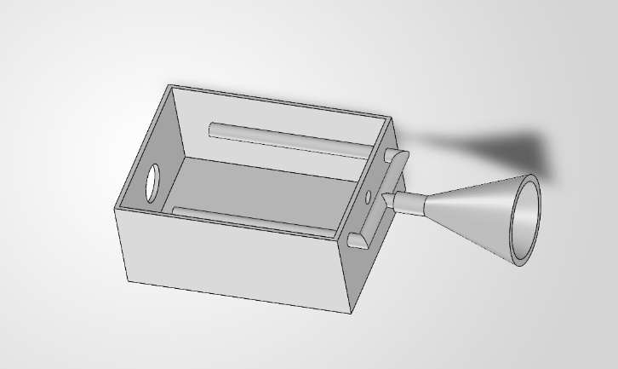
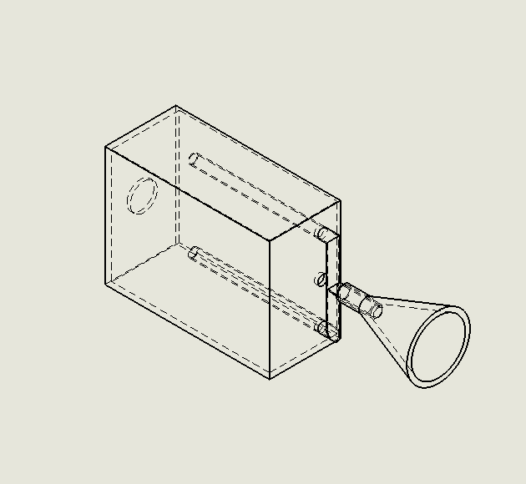
Figure 2: Isometric view of the complete assembly (Project Capstone Model)
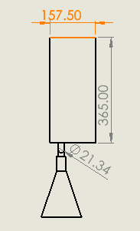
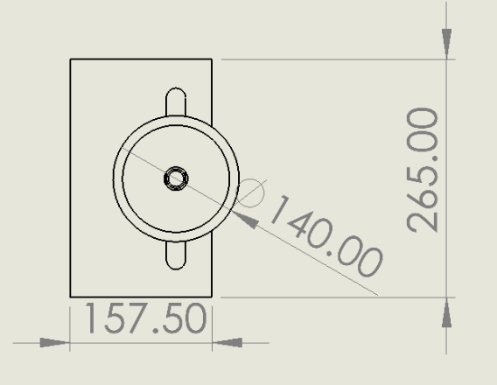

Figure 3: Front view of the assembly Figure 4: Side view of the assembly
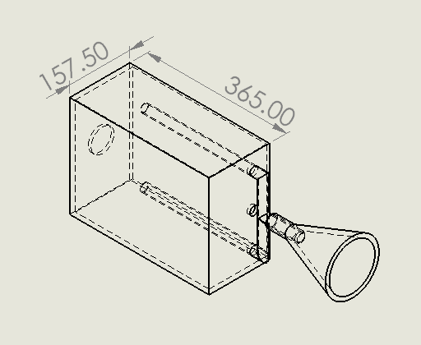
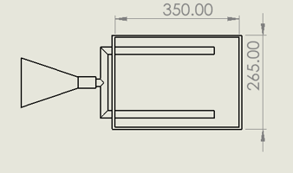

Figure 5: Top view of the assembly Figure 6: Dimensioned engineering drawing

4.10 Role of the CAD Model in Dimensional Control, Fit, Fabrication and Modification
- Dimensional control: all dimensions originate from one model, so drawings and the cutting list are consistent.
- Component fit: the assembly shows whether the fan, heater and pipes fit within the housing before material is cut.
- Fabrication planning: panel sizes, opening positions and assembly sequence are read from the model.
- Future modification: changes such as a larger outlet or different pipe position can be tried in the model first.

CHAPTER 5: PHYSICAL PROTOTYPE DEVELOPMENT
This chapter documents the actual fabrication and assembly. The physical prototype has been fabricated. Detailed records of tools, procedures, dates and observations were not supplied, so the entries below are structured prompts to be completed by the team from their own records. Nothing in this chapter should be treated as a confirmed observation unless it has been completed or confirmed by the team.

5.1 Materials Procured
Table 2: Materials procured for the prototype
Item | Description (as procured) | Quantity
Plywood | Housing panels; thickness [mm] | 7 plywood  250 x 150 mm (2)  350 x 150 mm (2)  250 x 150 mm  (2)  350 x 250 (1) [for stand]
PVC pipe | Two air-distribution pipes; diameter [mm] | 2 pipes
Fan | 12 V DC fan; model [to be entered] | 1
Heating element | Intended for 230 V AC; rating [W]  (Use of Hair Dryer ) | 1

5.2 Step-by-Step Fabrication
Table 3: Fabrication and assembly steps
Step | Operation | Description / observation
1 | Panel marking | Marking of plywood panels using dimensions from the SolidWorks model , considering 70 mm margin for making a cuboid
2 | Panel cutting | Portable Plywood Cutter
3 | Preparation of openings | [Fan opening, pipe entries, side-wall outlet]
4 | Enclosure fabrication | Pinned together using Glue & Iron Nails
5 | PVC pipe cutting and positioning | Hacksaw blade (Portable)
7 | Heating assembly | Wiring, supply arrangement for 12 V DC fan and 230 V AC heater
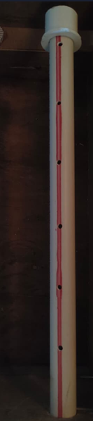
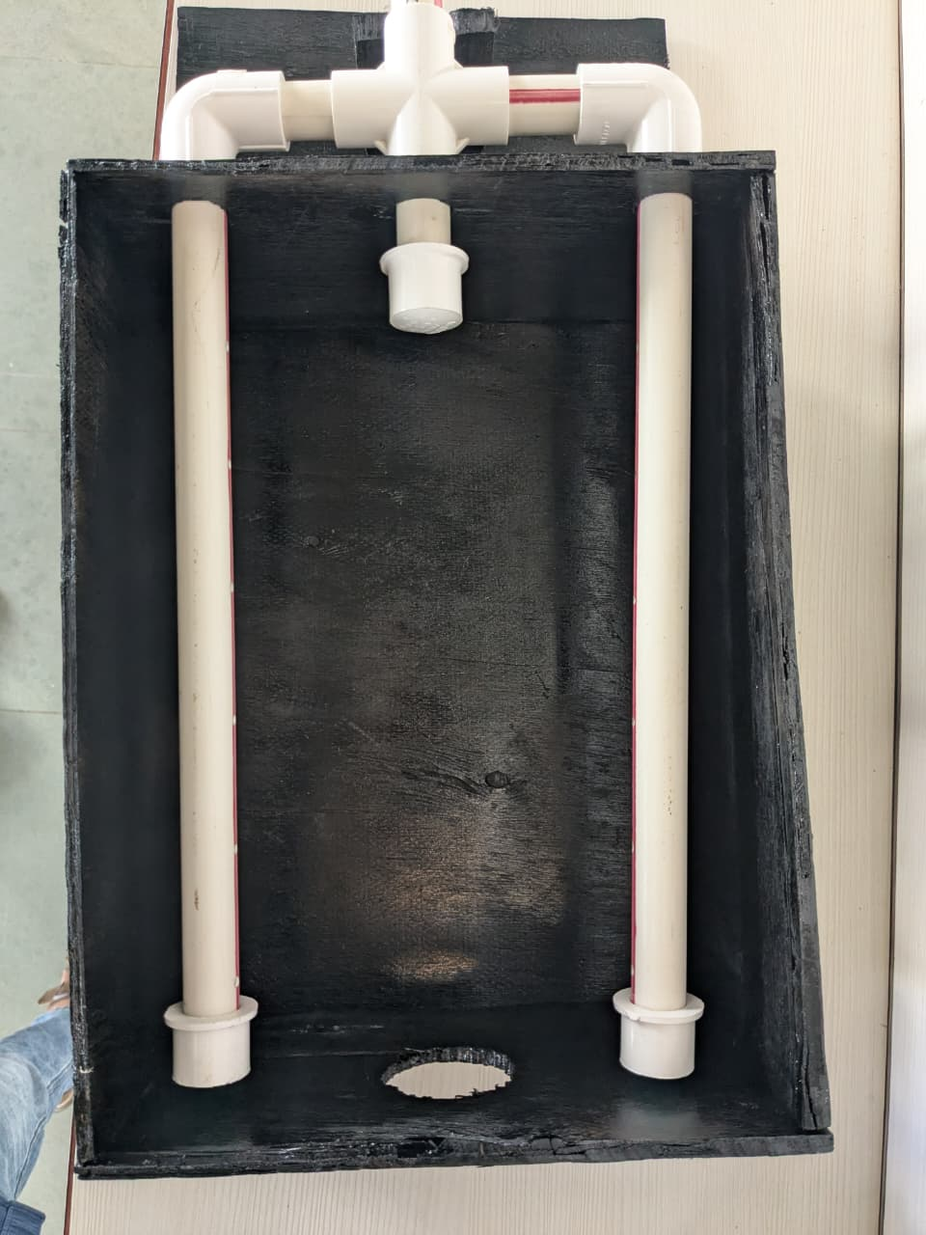
Prototype of the Project

Equi-distant holes in pipe for Air Flow

CHAPTER 6: WORKING PRINCIPLE AND SYSTEM DESCRIPTION

6.1 Intended Sequence of Operation
- Air enters through the intake.
- The fan moves the air through the system.
- The heating element warms the air.
- The two PVC pipes direct the warm air towards the shoes.
- Heat transfer from the air to the shoes supports moisture evaporation.
- Humid air leaves through the outlet, described as being in a side wall.
The order of components along the air path (for example whether the fan is upstream or downstream of the heater) must be confirmed from the SolidWorks model; the sequence above reflects the intended arrangement as described.

6.2 Functional Block Diagram
Air intake | → | Fan (12 V DC) | → | Heating element (230 V AC) | → | Two PVC pipes | → | Shoes | → | Side-wall outlet
Figure 6: Functional block diagram (conceptual)

6.3 Airflow Schematic
Ambient air enters at intake
↓
Fan drives air
↓
Air is heated by heating element
↓
Warm air splits into PVC pipe 1 and PVC pipe 2
↓
Warm air flows over / into shoes; moisture evaporates
↓
Humid air leaves through side-wall outlet
Figure 7: Airflow route (conceptual schematic; confirm against model)
This schematic is a conceptual illustration. It is not a CFD result, and airflow uniformity has not been verified.

6.5 Forced Convection
When a fan moves air past a warmer or cooler body, heat is transferred by forced convection. The rate of heat transfer from the air to a surface is given by Newton’s law of cooling:
Q = h A (Tair − Ts) (1)
where Q is the heat transfer rate (W), h is the convective heat transfer coefficient (W/m²·K), A is the surface area (m²), Tair is the air temperature and Ts is the surface temperature (°C or K) [1]. A higher air velocity generally increases h, which is why a fan-driven flow dries a shoe faster than still warm air.

6.6 Evaporation and Moisture Removal
Moisture within the shoe material migrates to the surface and evaporates into the passing air. The warm air provides the latent heat required and carries the water vapour away. Warmer air can hold more water vapour before becoming saturated, and replacing humid air with fresh air maintains the driving force for evaporation [3], [4]. For this reason the outlet is essential: without a path for humid air to escape, the air in the chamber would become saturated and drying would stall.
No claim is made here that the prototype’s airflow is uniform or that drying performance is adequate; these require the measurements described in Chapter 9.

CHAPTER 7: MATERIAL AND COMPONENT SELECTION

7.1 Component Table
Specifications not supplied are shown as Safety devices are listed only as recommendations and are not described as installed.
Table 4: Component and material selection
Component | Material / type | Qty | Function | Specification | Justification | Status
Housing | Plywood | 6 | Enclosure for shoes and components | Thickness  7 [mm] | Low cost, easy to cut and join | Material confirmed; spec to be verified
Air pipes | PVC | 2 | Direct warm air towards shoes | Dia. [mm]; temp. rating [to be confirmed] | Low cost, easy to cut | Material and number confirmed; spec to be verified
Fan | DC fan | 1 | Moves air through the system | 12 V DC (intended); flow | Small size, low voltage | Voltage intended; datasheet needed
Heating element | Electric heating element | 1 | Heats the air | 230 V AC (intended); power [W] | Provides warm air | Supply intended; rating needed

7.2 Plywood Housing
Plywood is chosen for convenience and cost. Its main drawback is combustibility: wood and wood-based panels can char and ignite after sustained heating, and their behaviour depends on temperature, exposure time and the specific product [6]. The heating element should therefore not be placed in direct contact with, or close to, the plywood without an appropriate non-combustible barrier and a suitable clearance. Adhesives, edge sealing and any surface coatings used on the plywood should also be checked for their own thermal limits.

7.3 PVC Piping
Rigid PVC pipe is easy to work with, but it softens at relatively modest temperatures compared with metals. The maximum service temperature depends on the pipe grade and manufacturer; the value for the pipe actually used must be taken from its datasheet or marking before it is used next to a heater. Until it is verified, no statement is made that the pipes are suitable for the heater outlet temperature. The reported air temperature of about 40–45 °C is preliminary, and the temperature at the point where hot air first enters the pipes may differ from it.

7.4 Fan
A 12 V DC fan is intended. A suitable DC supply (for example a regulated adapter or power supply) is required, and its rating must be matched to the fan’s current requirement. The fan’s airflow rate and static pressure capability should be read from its datasheet.

7.5 Heating Element
The heating element is intended to operate from 230 V AC. Its power rating determines the possible temperature rise of the air (Chapter 8). Because mains-voltage wiring is involved, connections must be properly insulated and enclosed, and the installation should be inspected by a qualified person before use.

7.6 Electrical Wiring, Switches, Temperature Control and Safety Devices
The wire and switch ratings must exceed the heater current. Temperature control and protective devices (fuse, thermal cut-off) are recommended in Chapter 12. They are described there as recommendations; they should be reported as installed only if the team confirms that they are installed.

7.7 Thermal Barrier, Fasteners and Brackets
A non-combustible thermal barrier between the heater and the plywood is recommended; if one was fitted, it should be described here with its material. Fasteners and brackets should be selected so that they do not conduct excessive heat to the plywood or loosen with vibration from the fan.

CHAPTER 8: TESTING AND PERFORMANCE EVALUATION

8.1 Status of Reported Data
An air temperature of approximately 40–45 °C has been reported for the prototype. This value is preliminary. Its measurement method (instrument and its accuracy), measurement location (heater outlet, pipe outlet or inside the chamber), the ambient condition and the operating duration have not been confirmed. It should not be used as a verified performance figure.

8.2 Test Conditions and Safety
- Carry out the first tests with a person present at all times and with the machine placed on a non-combustible surface in a ventilated area.
- Check the wiring and connections before connecting the supply.
- Record ambient temperature and relative humidity before and during each test.
- Use the same type of shoes, the same wetting procedure and the same starting condition for each trial.
- Repeat each test at least three times, and report the individual values as well as the average.

8.3 Test Procedure
- Record ambient temperature and relative humidity.
- Wet the shoes in a defined manner (for example, soak for a fixed time and drain for a fixed time), then weigh them (initial mass).
- Place the shoes in the machine and fit the temperature sensors at the positions to be monitored.
- Start the fan and heater and begin timing. Record temperatures and electrical readings at regular intervals (for example every 10 minutes).
- Measure the airflow at each pipe outlet using an anemometer, if available.
- Weigh the shoes at fixed intervals (this requires stopping the heater) and at the end of the test.
- Record the total drying time, and total energy from an energy meter.
- Switch off, allow to cool, and inspect plywood and PVC for discolouration, softening or deformation.

CHAPTER 9: RESULTS AND DISCUSSION
This chapter reports only what is supported by the information supplied. Where information is missing, this is stated, and blank tables are given. No results or graphs have been created.

9.2 Prototype Outcomes
Table 5: Prototype outcomes
Item | Status
Fabrication | Physical prototype fabricated
Housing and pipes | Plywood housing; two PVC pipes & one for inlet
Heating / air movement | Fan-assisted heating element
Air temperature | Approx. 40–45 °C reported

9.3 Limitations
- Missing data: CAD dimensions, component specifications, airflow, drying time, energy and cost records were not available.
- Unverified assumptions: location and method for the reported 40–45 °C; temperature rating of the PVC pipes and the fan and heater specification.
- Design constraints: the plywood housing and PVC pipe limit the safe operating temperature and the allowable closeness to the heater.
- Further testing: repeated trials under controlled conditions, airflow measurement, energy measurement and temperature monitoring of the housing.

CHAPTER 10: SAFETY, LIMITATIONS AND FUTURE SCOPE
This chapter states safety recommendations. Unless confirmed by the team, they are recommendations and are not implemented features of the prototype.

10.1 Electrical Safety
The machine uses a 230 V AC heater, which is hazardous. All live connections should be insulated and enclosed so that no live part can be touched, the housing and any metal parts should be properly earthed where applicable, and the wiring should be rated for the heater current. The fan’s 12 V DC supply should be taken from a properly isolated power supply. The completed machine should be inspected by a qualified electrician before regular use. General requirements for household electrical appliances are given in IEC 60335-1 [7]; the applicable national standard and edition should be confirmed.

10.2 Overcurrent and Overtemperature Protection
It is recommended that a correctly rated fuse or circuit breaker be used in the heater supply, and that an adjustable thermostat and a non-resettable (or manually reset) thermal cut-off be fitted near the heater so that the heater turns off if the fan fails or air flow is blocked. A heater must not be operated without airflow.

10.3 Plywood Fire Risk
Plywood is combustible [6]. Recommended measures include keeping the heating element well clear of the wood, using a non-combustible barrier (for example a suitable mineral-based board or metal shield with an air gap) between the heater and the plywood, and not leaving the machine unattended during early trials.

10.4 PVC Thermal Suitability
PVC softens when heated. The maximum service temperature of the actual pipe must be confirmed. If the air entering the pipes may exceed that limit, then a temperature-rated duct material (for example a metal duct near the heater) or a longer section before the PVC should be considered. The fan should be positioned so that the PVC does not receive radiant heat directly from the element.

10.5 Safe Heater Mounting
The heating element should be mounted rigidly on a heat-resistant support, with free air flow around it and adequate distance from all combustible surfaces and wiring.

10.6 Ventilation and Moisture Exposure
The outlet must remain unobstructed so that humid air can escape. Wet shoes release water and the interior of the machine may become damp; electrical parts should be kept away from dripping water, and a drip tray or non-absorbent base is recommended. Plywood that remains damp may swell or delaminate, so it should be sealed with a coating that is suitable for the temperatures involved.

10.7 Maintenance
- Inspect wiring, connectors and insulation regularly.
- Clean dust from the fan and the air passages.
- Check pipes for softening or deformation and plywood for discolouration.
- Replace damaged parts before use.

10.8 Future Scope
Table 6: Proposed improvements (not implemented unless stated)
Improvement | Purpose
Temperature controller / thermostat | Maintain a safe, set air temperature
Timer | Automatic shut-off after set drying period
Humidity sensing | Detect end of drying
Improved airflow design | More uniform air distribution; CFD analysis
Energy monitoring | Measure power and energy
Improved thermal design | Insulation, barrier and temperature-rated ducting
Temperature-rated ducting | Replace PVC where temperature requires

CHAPTER 11: CONCLUSION

11.1 Solid Modelling
A SolidWorks assembly of the shoe drying machine has been developed. The model provides the basis for dimensional control, fit checking and fabrication planning.

11.2 Prototype Development
A physical prototype with a plywood housing, two PVC air-distribution pipes and a fan-assisted heating element, sized for one pair of shoes, has been fabricated. A preliminary air temperature of about 40–45 °C has been reported, but its measurement conditions are yet to be confirmed. Airflow, drying time, moisture removal and energy consumption have not yet been documented, and no performance claim is made.

11.3 Application of Mechanical Engineering Principles
The project applied engineering graphics and solid modelling, heat transfer (forced convection and evaporation), fluid flow, material selection and manufacturing methods to a practical product. It also showed how a CAD model supports fabrication and how real-world observations feed back into design.

11.4 Way Forward
Priority work is to verify the CAD dimensions, to confirm component ratings, to add the recommended safety measures, and to carry out the repeated, instrumented tests defined in Chapter 9 so that performance can be stated with evidence.

REFERENCES
The references below are standard textbooks and handbooks. Edition and year are marked because they depend on the copy used by the team and must be completed in IEEE format before submission. Add every additional source actually used (datasheets, standards, websites with access dates).
[1] F. P. Incropera, D. P. DeWitt, T. L. Bergman and A. S. Lavine, Fundamentals of Heat and Mass Transfer. Hoboken, NJ, USA: Wiley,
[2] Y. A. Çengel and A. J. Ghajar, Heat and Mass Transfer: Fundamentals and Applications. New York, NY, USA: McGraw-Hill,
[3] A. S. Mujumdar, Ed., Handbook of Industrial Drying. Boca Raton, FL, USA: CRC Press,
[4] R. E. Treybal, Mass-Transfer Operations. New York, NY, USA: McGraw-Hill,
[5] Dassault Systèmes, SolidWorks Help and user documentation.
[6] Forest Products Laboratory, Wood Handbook: Wood as an Engineering Material. Madison, WI, USA: U.S. Department of Agriculture, Forest Service.

